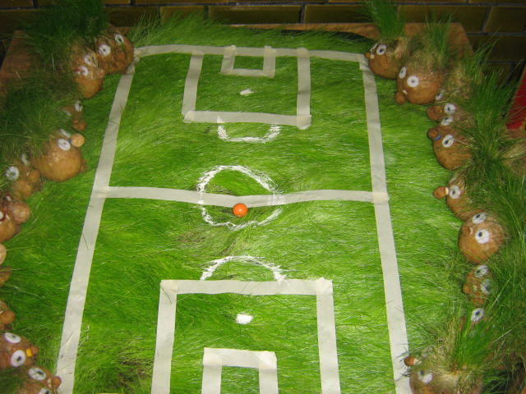 \

MATCH REPORT

SUIS League Wan Yuan B Vs Gubei 26 / 04 / 13

Wan Yuan B hosted Gubei at the Hongqiao campus for this SUIS league fixture. Wan Yuan B had been considerable weakened by the loss of Bill, Brian Aden and Harry. However the team did have in form striker Peter Red available and this indeed proved to be the difference.   
  
Both sides started slowly with few chances in the opening exchanges. Gubei had brought a talented squad with some outstanding individuals. Indeed the first real chance fell to Gubei, producing a fine save from Miguel in the Wan Yuan goal. But it wasn’t long until Wan Yuan settled into their passing game creating the first Chance for Peter Red, who converted with a blistering close range shot.  
Moments later a fine ball from Alex found Peter Red again to make it 2 - 0. More chance were created by the home side, but they could not add to their tally before the break.   
  
The second half saw a change in tactics from Wan Yuan, opting to play only two in defense and attempt to put some distance between the two sides. Peter Red began to cause chaos in the heart of the Gubei defense. Shot after shot was either blocked or saved. However it was defender William who added the third. Rising above the Gubei defense a fine header powered into the Gubei net for 3- 0.  
  
The Wan Yuan went to sleep, Gubei rallied and scored two goals in quick succession. One however was given when it was believed the ball had indeed gone out of play. The other a blunder by the normally solid Miguel. For a time Gubei applied all the pressure but to no avail. It was not long until the two goal lead was re-established. Peter Red completing his hat - trick with a fine goal.  
  
Gubei did come back and score a third, a breakaway from a Wan Yuan corner left the goalkeeper with no chance. This saw a nervous final few minutes for the Wan Yuan team to get through. A sense of relief at the final whistle, a game that seemed to be more difficult that it had to be. Credit Gubei who never gave up and at 3 - 0 down looked dead and buried.