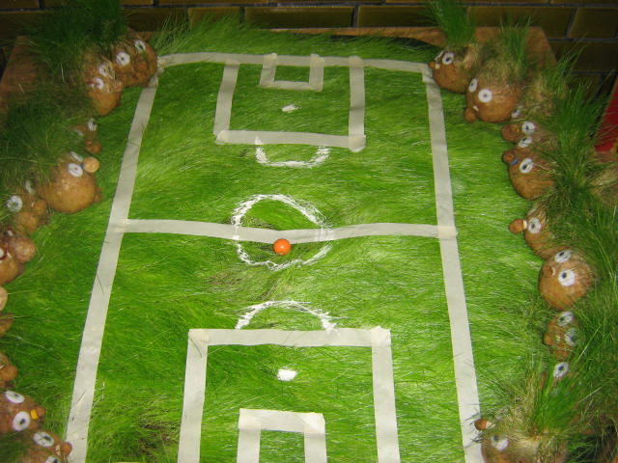 \

MATCH REPORT

WAN YUAN VS JIAOKE - FRIENDLY 22/04/13

On Monday 22nd April Wan Yuan hosted Jiaoke for that rare event, a home fixture. A large crowd turned out to support both teams and the stage was set for the two teams to do battle.   
  
Battle they did. On a pitch that would lend itself more to growing potatoes than playing football, both teams set about each other at a blistering pace. Early on the tone of the games was set as being hard, physical but fair. A game that had bite and edge, almost threatening to bubble over but never reaching melting point. A game that as a team we really needed. A game that was going to require guts, grit and determination to win.   
  
From the beginning it was clear that Wan Yuan's usual style of pass and move was going to be difficult to excute on this field. The possession of the ball changed hands time and time again with neither side being able to establish any control. Both defenses were redundant for the first 15 as the game became bogged down in midfield head tennis. Eventually though the breakthrough came. Some excellent work form Bill, Aden and finally Moto who set returning club captain Max free. Three months on the sidelines made no difference as he calmly slotted the ball home.   
  
The next 10 were largely uneventful, both sides competing hard but failing to carve out any real chances. Peter Red did have a penalty claim waved away and both side prodded and probed but to no avail. Then with 8 minutes left in the first half Jiaoke equalized. It came out of nothing really, ball stuck in midfield, a fortunate bounce brought the ball clear, followed by a first time shot from 30 yards that sailed over Miguel's head.   
  
This seemed to focus Wan Yuan and for the time remaining in the half they asserted their dominance. Pressure mounted on the Jiaoke backline and eventually it broke. A long ball from Steven found Aden clear on the right wing. Some clever foot work enabled him to wriggle clear and charge towards goal. An early shot burst the net into the top left corner beyond the keeper.  
  
The second half continued as the first had ended. Neither team was dominant but Wan Yuan certainly looked the more comfortable of the two. Jiaoke never really threatened to score whilst Wan Yuan created rare chances. Wan Yuan did have the ball in the back of the net, but this was disallowed as the free kick was taken before the whistle.   
  
The final goal came from Bill. Again good work by Peter on the wing and link play with Peter Red, put the midfielder through to score and make it 3 - 1.   
  
3 - 1 was a fair result, Wan Yuan won and won ugly. It had been a while since they have had to do that. Accept that physical challenges will be hard and fair. Accept that long ball football sometimes has to be played and be able to mix and match different styles. Also it had been a while since they team had played a full 11 a side game so overall a pleasing performance. Pictures in the gallery area of the site.

